Wireshark
is a free, open-source network protocol analyzer that allows you to capture and interactively browse the traffic running on a computer network. It is considered the industry standard for network analysis, troubleshooting, and security.

What Wireshark Does
Think of Wireshark as a "microscope" for your network cables. It intercepts data packets—the tiny chunks of information your computer sends and receives—and translates them into a human-readable format so you can see exactly what's happening on your network.

- Real-Time Capture: It captures live traffic from network interfaces like Wi-Fi, Ethernet, Bluetooth, and USB.
- Deep Inspection: You can "drill down" into a single packet to see its source, destination, protocol (like HTTP or DNS), and specific contents.
- Filtering: Since networks are noisy, Wireshark uses powerful filters to let you focus only on the traffic you care about, such as finding a specific IP address or isolating a single conversation.
- Troubleshooting: It helps identify issues like slow internet speeds, dropped connections, or misconfigured devices by showing where bottlenecks occur.

Who Uses It and Why
Because of its high level of detail, Wireshark is used by a variety of professionals:
- Network Administrators: To troubleshoot performance issues and find the cause of network crashes.
- Security Professionals: To detect suspicious activity, such as malware communicating with a command-and-control server or "man-in-the-middle" attacks.
- Developers: To debug network applications and verify that protocols are working correctly.
- Students: To learn how computer networking actually works by seeing real packets in action rather than just reading about them in a textbook.

Important Limitations
- It is not an alarm system: Wireshark won't alert you when something goes wrong; it is a measurement tool that helps you investigate after you notice a problem.
- Encryption: It cannot read the contents of encrypted traffic (like HTTPS) unless you provide the necessary decryption keys.
- Passive tool: It only listens to the network; it does not block traffic or send its own packets.

You can download it for Windows, macOS, or Linux directly from the official Wireshark website.

Download Wireshark
https://www.wireshark.org/download.html

Wireshark: Your Network Analysis Tool
choose Wi-Fi and start analysis

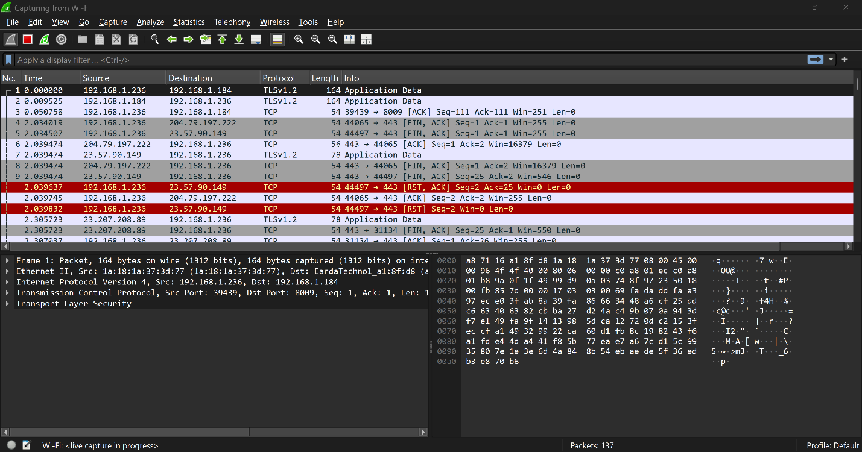

Notes
If you don't know the target's IP yet:
- By Protocol: To find a target doing a specific activity (e.g., HTTP or DNS):
http or DNS.

- Endpoints List: Go to Statistics > Endpoints and click the IPv4 tab. This lists every device Wireshark has seen, sorted by how much data they are sending.
- Promiscuous Mode: Ensure this is enabled in Capture > Options. Without it, you may only see traffic specifically meant for your computer, missing other targets on the network

Using Capture Filters (Pre-Capture)
If you want to only record traffic for one specific machine to save space:
- Go to Capture > Options.
- In the "Capture Filter" box for your interface, type
How to take Ip off traffic from network by use Wireshark

- Go to the Statistics menu at the top.
- Select Endpoints.
- Click the IPv4 or IPv6 tab.
- ou will see a unique list of every IP address that sent or received data. You can click the Copy or Export button to save this list as a CSV for use in Excel.

